

**Proposed 18-unit Residential Townhome Subdivision**

**Access the project webpage below:**

[www.OVprojects.com](http://www.OVprojects.com) under the project name **East corner of Rancho Vistoso and Morning Vista – Residential Subdivision Site Design, 2003075**

**Project Summary**

The applicant is proposing an 18-unit residential townhome subdivision at the east corner of the Rancho Vistoso Blvd and Morning Vista Dr intersection (see map on this page).

**Proposed Change:**

New development of 18 townhomes on a vacant 3.5-acre site.

**Meeting Dates**

1. First neighborhood meeting –

May 20, 2021

1. Second neighborhood meeting – TBD
2. Planning and Zoning Commission – TBD
3. Town Council – TBD

**Project milestones**

1. Pre-Application submitted – April 2021
2. First neighborhood meeting – May 20, 2021
3. Formal submittal – anticipated after 1st neighborhood meeting

**Meeting format**

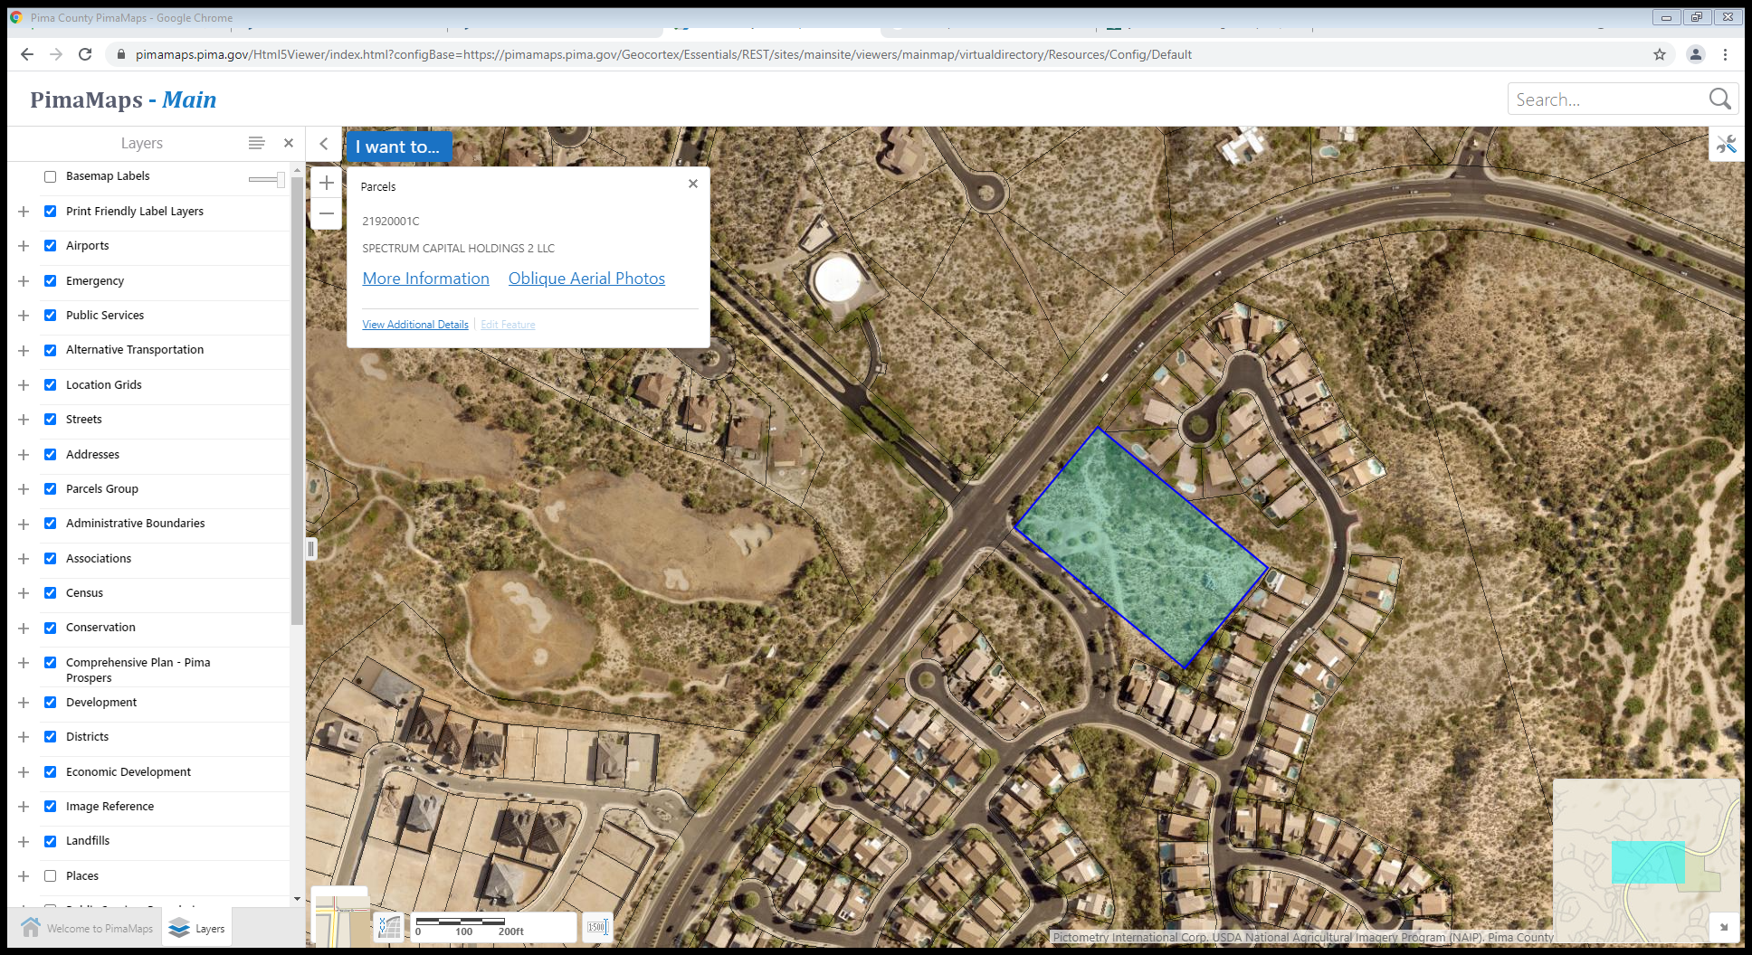Standard meeting format

* Introduction – 10 minutes
* Staff Presentation – 10 minutes
* Applicant Presentation – 20 minutes
* Question and Answer – 50 minutes

Morning Vista Dr

Rancho Vistoso Blvd

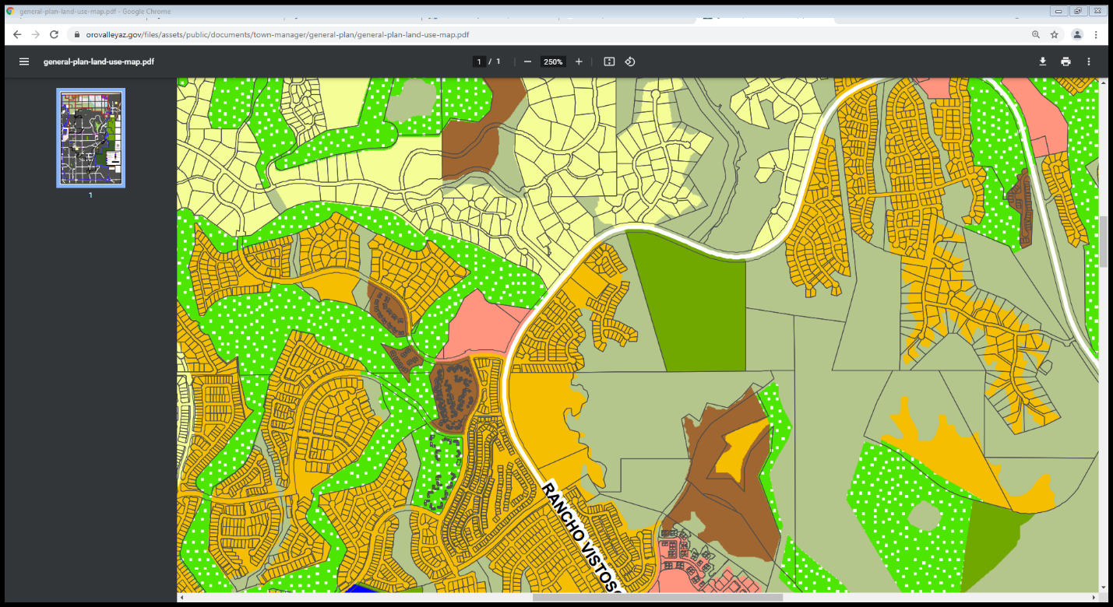**General Plan Designation**

The General Plan is a policy document which helps inform land use decisions in the community and embodies the values and goals of the community and its residents. The subject property has a designation of Medium Density Residential.

Low Density Residential

*Medium Density Residential*

*This land use designation represents areas where single-family home, townhouse or patio home development is appropriate.*

Park

Medium Density Residential

Golf

**Existing Zoning Designation**

The subject property has a zoning designation of High Density Residential in the Rancho Vistoso Planned Area Development (PAD), which permits multiple-family and single-family dwelling units, including townhomes.

Open Space

**Development Standards**

The following standards are applicable for this site:

* Building height – 34 feet
* Setbacks:

Low Density Residential

* + Front – 20 feet
  + Side – 5 feet, or 0 feet where a wall is shared between dwelling units
  + Rear – 5 feet

High Density Residential

**Review Criteria**

Town Council Hearing

Please follow the link below to the Town of Oro Valley Zoning Code and General Plan.

Golf

<https://orovalley.town.codes/AreaPlans/RanchoVistosoPAD>

<https://www.orovalleyaz.gov/Government/Departments/Town-Managers-Office/General-Plan>

Existing Zoning

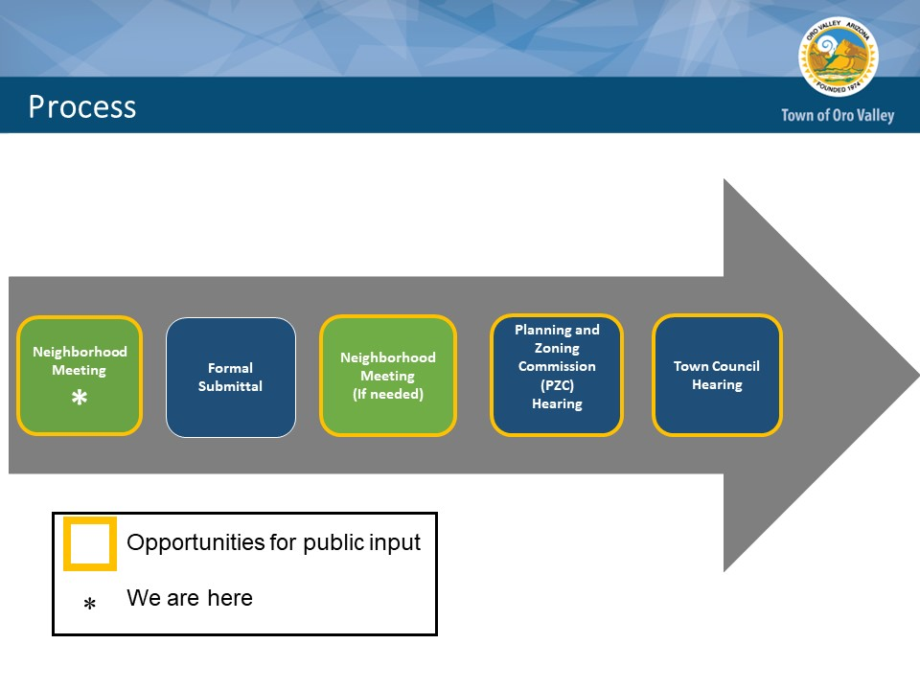**Review Process:**