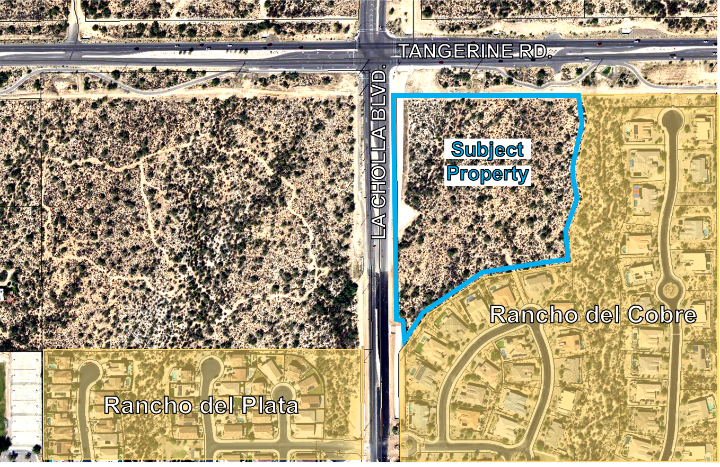

 | location MaP  SEC tangerien & la cholla type 1 general plan amendment and rezoning  (2200729)

